

Company Brochure



Contents:

About Fast Lane 03

Cisco Certifications 04

NetApp Certifications 06

Aruba Certifications 07

Fortinet Certifications 09

Infoblox Certifications 10

Nutanix Certifications 11

CompTIA Certifications 12

Microsoft Certifications 13

VMware Certifications 15

Palo Alto Certifications 18

CertNexus Certifications 19

VEEAM Certifications 20

Training Schedule 21

# About Fast Lane

Fast Lane was established in 1996 in Dubai with the aim to provide top quality IT training for professionals.

Contents

About Fast Lane **Error! Bookmark not defined.**

Cisco Certifications 4

NetApp Certifications 6

Aruba Certifications 7

Fortinet Certifications 9

Infoblox Certifications 10

Nutanix Certifications 11

VMware Certifications 15

VEEAM Certifications 20

Training Schedules **Error! Bookmark not defined.**

**Contact us: training@fastlane-mea.com**

**Contact us: training@fastlane-mea.com**

01

01

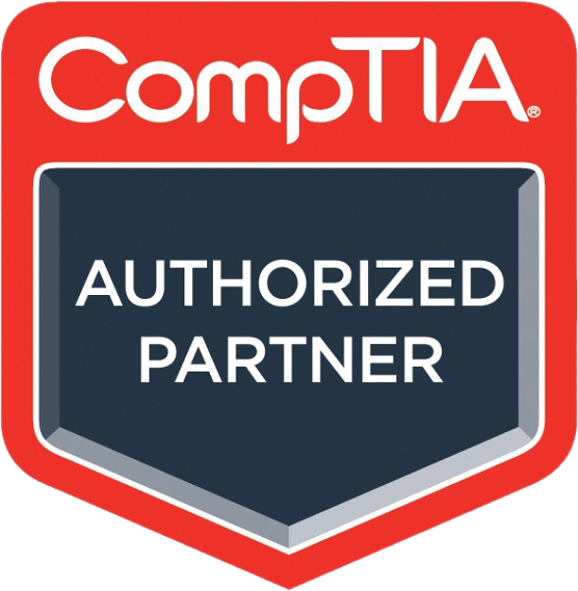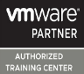

* Classroom at a Fast Lane Training Centre
* On-site team training
* Virtual Instructor-Led Training
* Meet customer expectation.
* Meet vendor expectation.
* Maintain professionalism and technical mastery as the foremost provider of network training.

Our Vendors

Our delivery methods

Our Vision and Mission

Fast Lane covers the EMEA region with dedicated offices in Austria, UAE and South Africa covering the EMEA region.

Our Locations



## Cisco Certifications

Performing CyberOps Using Cisco Security Technologies

(CBRCOR)

Developing Applications Using Cisco Core Platforms and APIs

(DEVCOR)

Implementing and Operating Cisco Security Core Technologies

(SCOR)

Implementing and Operating Cisco Data Centre Core Technologies

(DCCOR)

Implementing and Operating Cisco Service Provider Network Core Technologies

(SPCOR)

Implementing and Operating Cisco Enterprise Network Core Technologies

(ENCOR)

**Exam 350-201**

**Exam 350-901**

**Exam 350-801**

**Exam 350-701**

**Exam 350-601**

**Exam 350-501**

**Exam 350-401**

**CyberOps Professional**

**DevNet Professional**

**CCNP Collaboration**

**CCNP Security**

**CCNP Data Center**

**CCNP Service Provider**

**CCNP Enterprise**

Professional

Implementing Cisco Collaboration Core Technologies

(CLCOR)

Developing Applications & Automating Workflows using Cisco Core Platforms

(DEVASC)

Implementing & Administering Cisco Solutions

(CCNA)

**CCNA**

**Exam 200-301**

**DevNet Associate**

**CyberOpsAssociate**

**Exam 200-201**

Understanding Cisco Cybersecurity Operations Fundamentals

(CBROPS)

**Exam 200-901**

**Exam CCST CyberSecurity**

**Exam CCST Networking**

Cisco Certified Support Technician (CCST) Networking

Cisco Certified Support Technician (CCST) Cybersecurity

**Certified Technician**

**Certified Technician**



Associate

Entry

Level

**Contact us: training@fastlane-mea.com**

01

**Exam 300-635**

Implementing Automation for Cisco Data Center Solutions (DCAUTO)

Implementing Cisco Application Centric Infrastructure–Advanced (DCACIA)

**Exam 300-630**

Developing Applications for Cisco Webex & Webex Devices (DEVWBX)

**Exam 300-920**

**CCIE Service Provider**

**Exam 350-501**

**Exam 300-915**

Developing Solutions using Cisco IoT & Edge Platforms (DEVIOT)

Implementing DevOps Solutions & Practices using Cisco Platforms (DEVOPS)

**Exam 300-910**

Implementing Automation for Cisco Collaboration Solutions (CLAUI)

**Exam 300-835**

Implementing Automation for Cisco Security Solutions (SAUI)

Implementing Automation for Cisco Data Center Solutions (DCAUI)

**Exam 300-635**

Implementing Automation for Cisco Service Provider Solutions (SPAUTO)

**Exam 300-535**

**Exam 300-435**

Implementing Automation for Cisco Enterprise Solutions (ENAUTO)

Conducting Threat Hunting and Defending using Cisco Technologies for CyberOps (CBRTHD)

Conducting Forensic Analysis and Incident Response Using Cisco Technologies for CyberOps (CBRFIR)

**Exam 300-220**

**Exam 300-215**

Implementing Cisco Advanced Call Control & Mobility Services (CLACCM)

Implementing Cisco Collaboration Conferencing (CLCNF)

Automating and programming Cisco Collaboration Solutions (CLAUTO)

**Exam 300-835**

**Exam 300-825**

**Exam 300-820**

**Exam 300-810**

**Exam 300-815**

Implementing Automation for Cisco Security Solutions (SAUTO)

**Exam 300-735**

Implementing Secure Solutions with Virtual Private Networks (SVPN)

**Exam 300-730**

Securing the Web with Cisco Web Security Appliance (SWSA)

**Exam 300-725**

Securing Email with Cisco Email Security Appliance (SESA)

**Exam 300-720**

Implementing & Configuring Cisco Identity Services Engine (SISE)

**Exam 300-715**

Securing Networks with Cisco Firepower Next Generation Firewall

+

Securing Networks with Cisco Firepower Next Generation IPS (SNCF)

**Exam 300-710**

Designing Cisco Data Center Infrastructure (DCID)

Troubleshooting Cisco Data Center Infrastructure (DCIT)

Implementing Cisco Application Centric Infrastructure (DCACI)

Configuring Cisco MDS 9000 Switches (DCSAN)

Implementing Cisco Service Provider Advanced Routing Solutions (SPRI)

Automating Cisco Service Provider Solutions (SPAUI)

**Exam 300-515**

Automating Cisco Enterprise Solutions (ENAUTO)

Implementing Cisco Enterprise Wireless Networks (ENWLSI)

Designing Cisco Enterprise Wireless Networks (ENWLSD)

Designing Cisco Enterprise Networks (ENSLD)

Implementing Cisco SD-WAN Solutions (SDWAN300)

Implementing Cisco Enterprise Advanced Routing & Services (ENARSI)

**Exam 300-435**

**Exam 300-430**

Implementing Cisco Collaboration Cloud & Edge Solutions (CLCEI)

**Exam 300-735**

Implementing Cisco Collaboration Applications (CLICA)

**Exam 300-625**

**Exam 300-620**

**Exam 300-615**

**Exam 300-510**

**Exam 300-535**

Implementing Cisco Service Provider VPN Services (SVPI)

**Exam 300-425**

**Exam 300-420**

**Exam 300-415**

**Exam 300-610**

**Exam 300-410**

Developing Applications Using Cisco Core Platforms and APIs (DEVCOR)

**Exam 350-901**

**Exam 400-007**

Cisco Certified Design Expert (CCDE)

**Exam 350-801**

Implementing and Operating Cisco Collaboration Core Technologies (CLCOR)

Implementing and Operating Cisco Security Core Technologies (SCOR)

**Exam 350-701**

Implementing and Operating Cisco Data Centre Core Technologies (DCCOR)

**Exam 350-601**

Implementing and Operating Cisco Service Provider Network Core Technologies (SPCOR)

**DevNet Expert**

**CCDE**

**CCIE Collaboration**

**CCIE Security**

**CCIE Data Center**

**CCIE Enterprise Infrastructure & Wireless**

Implementing and Operating Cisco Enterprise Network Core Technologies (ENCOR)

**Exam 350-401**

**CCNP Enterprise**

**CCNP Service Provider**

**CCNP Data Center**

**CCNP Security**

**CCNP Collaboration**

**DevNet Professional**

**CyberOps Professional**

Cisco Certifications

Expert

Professional

**Contact us: training@fastlane-mea.com**

01

**Expert**

**Associate**

**Professional**

**Specialist**

## NetApp Certifications

**Cisco and NetApp FlexPod Design Specialist**

(NS0-175)

**NetApp Certified Hybrid Cloud Implementation Engineer**(NS0-403)

**NetApp Certified Hybrid Cloud Administrator**(NS0-303)

**NetApp Certified Hybrid Cloud Architect**(NS0-603) Corequisite: cloud service provider certification

**Cisco and NetApp FlexPod Implementation and Administration Specialist**(NS0-176)

**NetApp Certified Professional BlueXP Cloud and Storage Services**

 (NS0-700)

**NetApp Certified Technology Associate**(NS0-003)

**NetApp Certified Data Administrator ONTAP**(NS0-162)

**NetApp Certified Storage Installation Engineer, ONTAP**(NS0-184)

**NetApp Certified Support Engineer**(NS0-194)

**NetApp Certified Implementation Engineer SAN Specialist, ONTAP**(NS0-520) Prerequisite: (NS0-162)

**NetApp Certified Implementation Engineer Data Protection Specialist**(NS0-527) Prerequisite: (NS0-162)

**NetApp Certified Implementation Engineer SAN Specialist, E-Series**(NS0-516)

**NetApp Certified Support Engineer ONTAP Specialist**(NS0-593) Prerequisite: NS0-194

**Contact us: training@fastlane-mea.com**

01

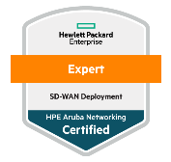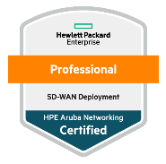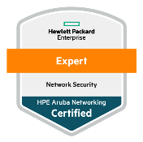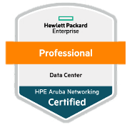

## Aruba Certifications

|  |  |  |
| --- | --- | --- |
|  |  |  |

+971 (4) 42 89 440

**ACSX**

**Training required:**

* Aruba Advanced OS CX Switching Troubleshooting & Solutions

**ACSP**

**Training required:**

* Implementing Aruba OS CX Switching

**Training required:**

* Aruba OS CX Switching Fundamentals

**ACSA**

**ACSDX**

**ACSDP**

**Training required:**

**Training required:**

* Deploying Aruba SD-WAN Technologies
* Advanced SD-WAN Deployments
* Troubleshooting SD-WAN Networks

**Training required:**

* Aruba Campus Access Fundamentals

**Training required:**

* Implementing Aruba Campus Access

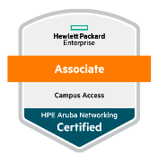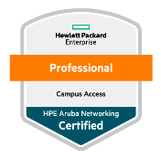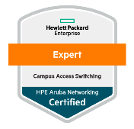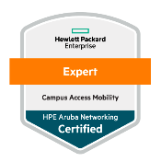

**ACA**

**ACP**

**CASX**

**CAMX**

**HPE Aruba Networking Certified Professional – Data Center**

**Training required:**

* Aruba Advanced Network Security
* Troubleshooting & Solutions

**Training required:**

* Implementing Data Center Networks
* Deploying Aruba SD-WAN Technologies
* Advanced SD-WAN Deployments
* Troubleshooting SD-WAN Networks
* Designing SD-WAN Networks

**SD-WAN**

* Implementing Aruba
* Network Security

**Training required.**

**Training required:**

* Aruba Network Security Fundamentals

**ACX**

**ACP**

**ACA**

**Security**

**Data Center**

**Switching**

**Training required:**

* Aruba Advanced Mobility Troubleshooting & Solutions

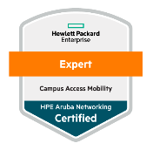

**ACMX**

Associate

Professional

Expert

**Campus Access**

**Wireless**

+971 (4) 42 89 440

06

01

**Contact us: training@fastlane-mea.com**

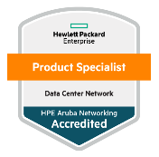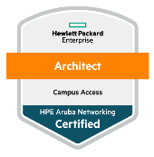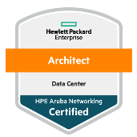

* [Designing HPE Aruba Data enter Solutions](https://inter.viewcentral.com/events/cust/cust_tracks.aspx?company_login_id=aruba&pid=1&track_id=38)

**Training required.**

**AASP**

**APS** **SD Branch**

**ACSDP**

**AASX**

**APSC**

**ADCNS**

**Training required:**

**HPE Aruba Networking Certified Network Architect – Data Center**

**HPE Aruba Networking Certified Network Architect − Campus Access**

* Designing HPE Aruba Campus Access Solutions

**Architect**

**Edge**

* [Aruba Certified Mobility Associate (ACMA)](https://www.arubanetworks.com/support-services/training-services/certified-mobility-associate/)
* [Aruba Certified Design Associate (ACDA)](https://www.arubanetworks.com/?page_id=201431)
* [Aruba Certified Switching Associate (ACSA)](https://www.arubanetworks.com/support-services/training-services/certified-switching-associate/)
* [Aruba Certified ClearPass Associate (ACCA)](https://www.arubanetworks.com/support-services/training-services/certified-clearpass-associate/)
* [Aruba Certified Associate (ACA) – Network Security](https://www.arubanetworks.com/support-services/training-services/certified-associate-network-security/)

**Training required:**

* [Aruba Certified Mobility Professional (ACMP)](https://www.arubanetworks.com/support-services/training-services/certified-mobility-professional/)
* [Aruba Certified Design Professional (ACDP)](https://www.arubanetworks.com/?page_id=133039)
* [Aruba Certified Switching Professional (ACSP)](https://www.arubanetworks.com/support-services/training-services/certified-switching-professional/)
* [Aruba Certified ClearPass Professional (ACCP)](https://www.arubanetworks.com/support-services/training-services/certified-clearpass-professional/)
* [Aruba Certified Professional (ACP) – Network Security](https://www.arubanetworks.com/support-services/training-services/certified-professional-network-security/)

**Training required:**

* [Aruba Certified Mobility Expert (ACMX)](https://www.arubanetworks.com/support-services/training-services/certified-mobility-expert/)
* [Aruba Certified Design Expert (ACDX)](https://www.arubanetworks.com/?page_id=133030)
* [Aruba Certified ClearPass Expert (ACCX)](https://www.arubanetworks.com/support-services/training-services/certified-clearpass-expert/)
* [Aruba Certified Switching Expert (ACSX)](https://www.arubanetworks.com/support-services/training-services/certified-switching-expert/)

**Training required:**

**ACEX**

**ACEP**

**ACEA**

**Product Specialist**

**APS CX 10000**

## Aruba Certifications



**NSE Level**

**Level Objective**

**NSE Level**

## Fortinet Certifications

**Contact us: training@fastlane-mea.com**

01

Certifications

**DDI Security Professional**

**DDI Professional**

**DDI Security Associate**

**DDI Associate**

Recommended Training:   
**DDI Security Professional Full Bundle**

Recommended Training:   
**DDI NIOS Professional Full Bundle**

## Infoblox Certifications

**Contact us: training@fastlane-mea.com**

01

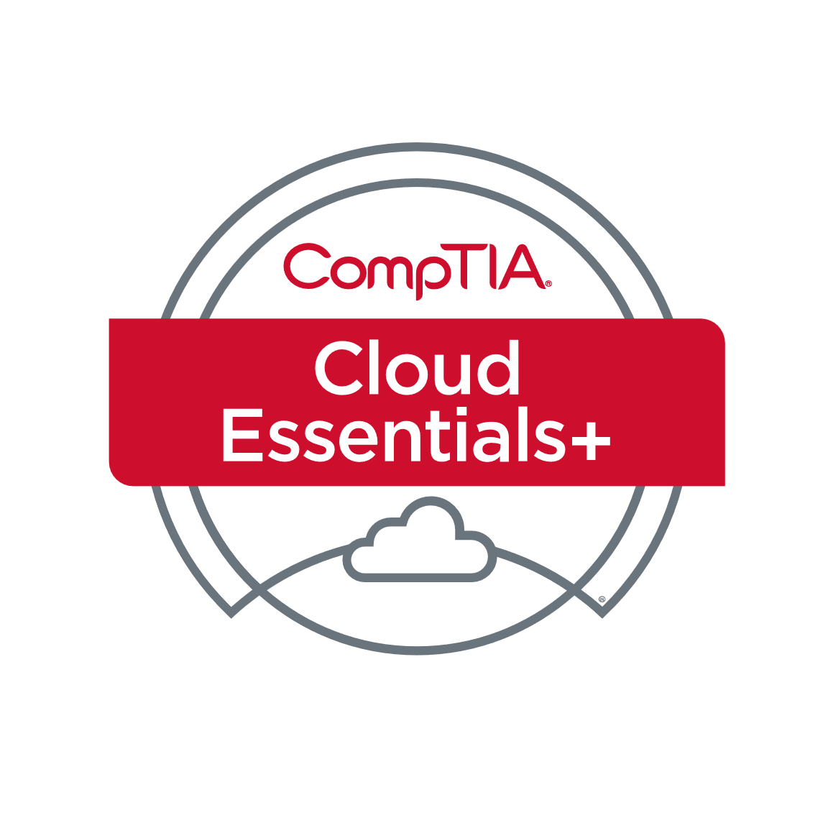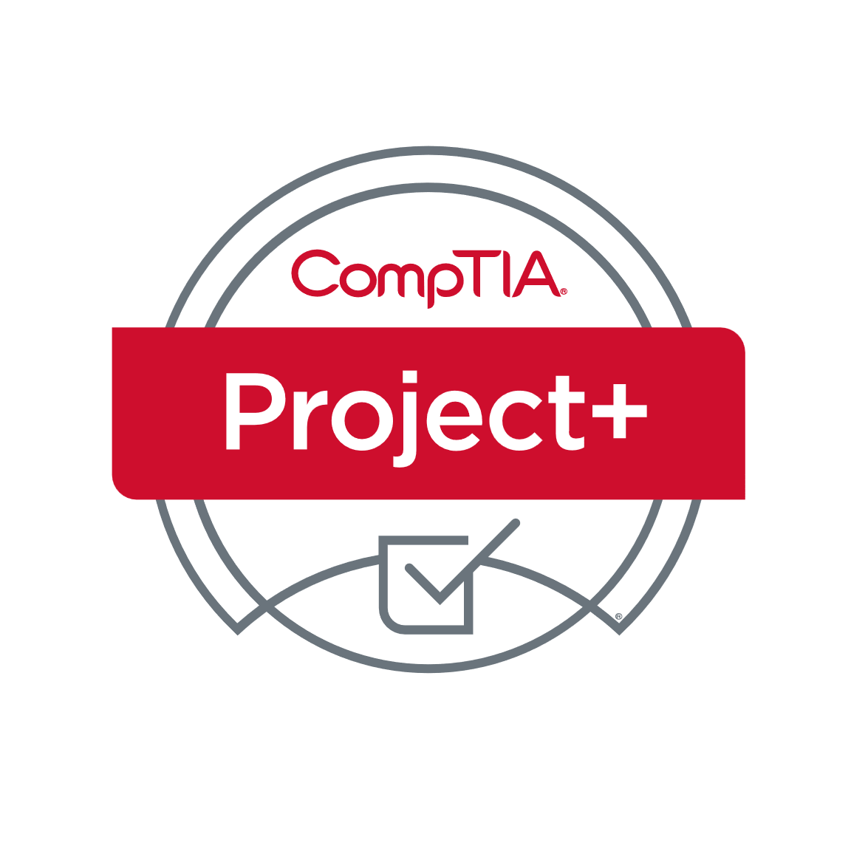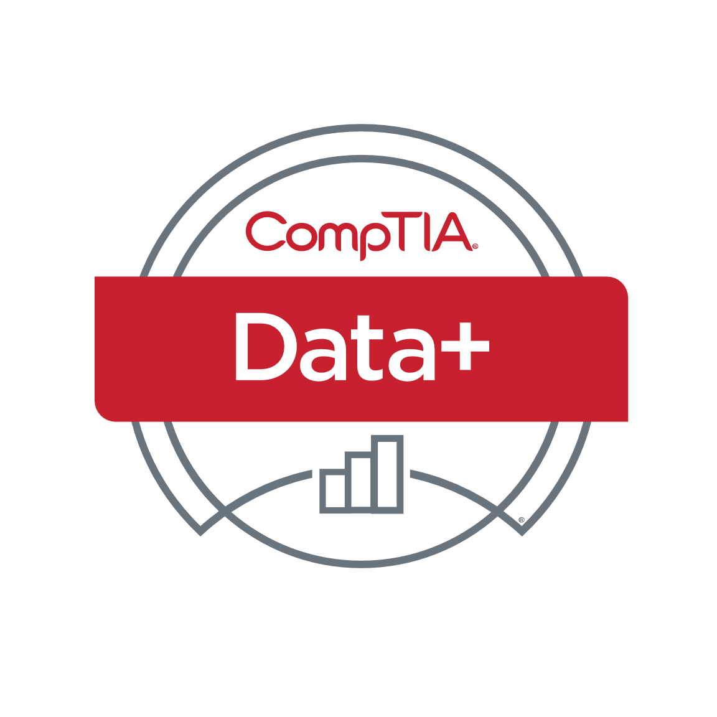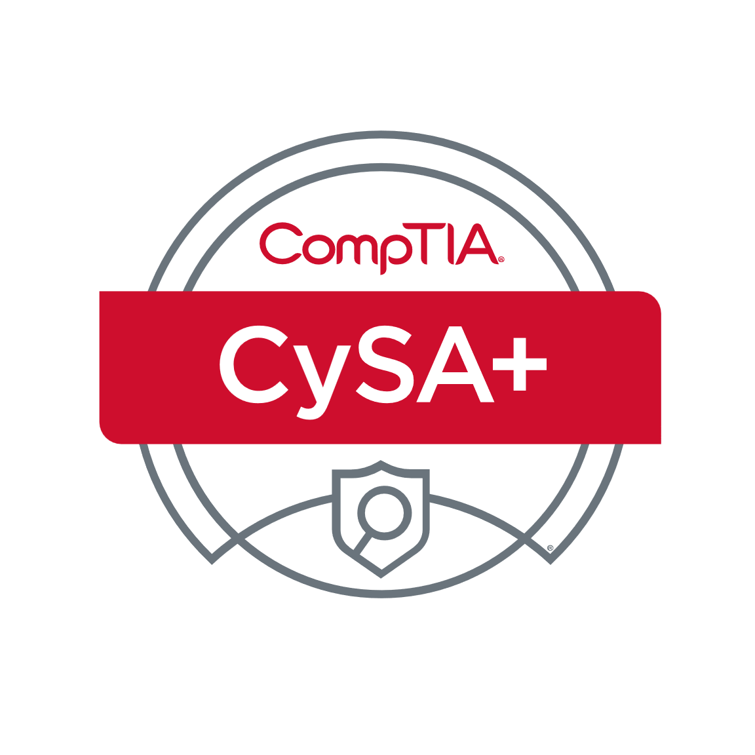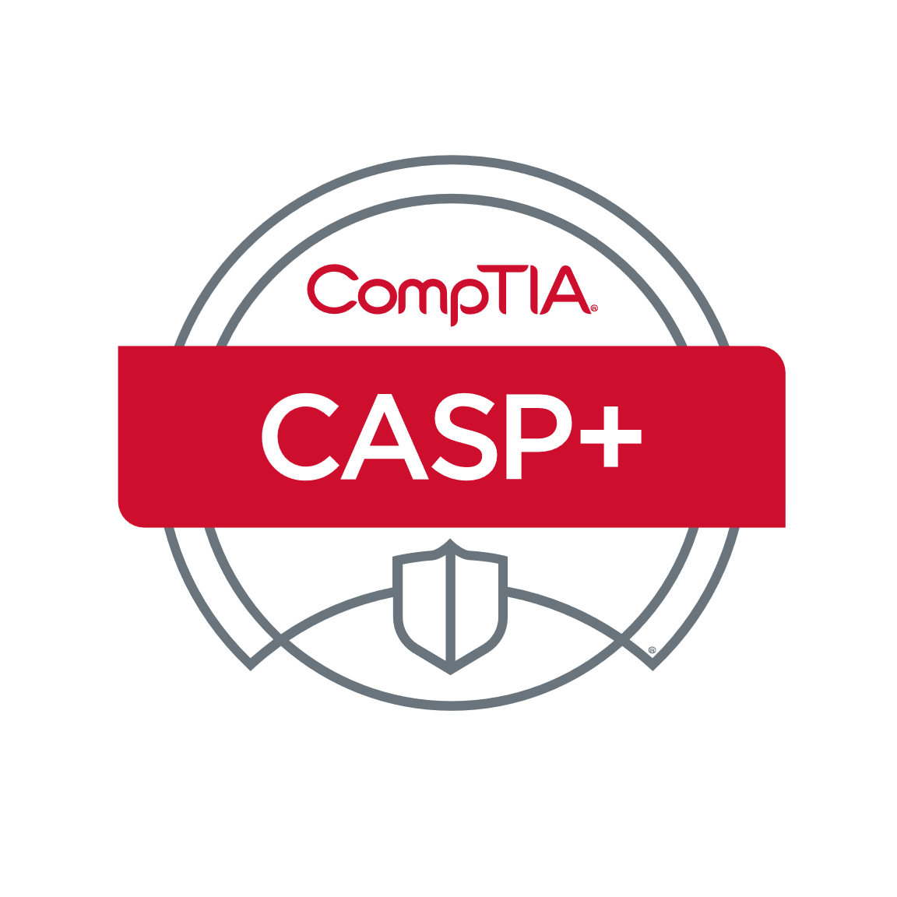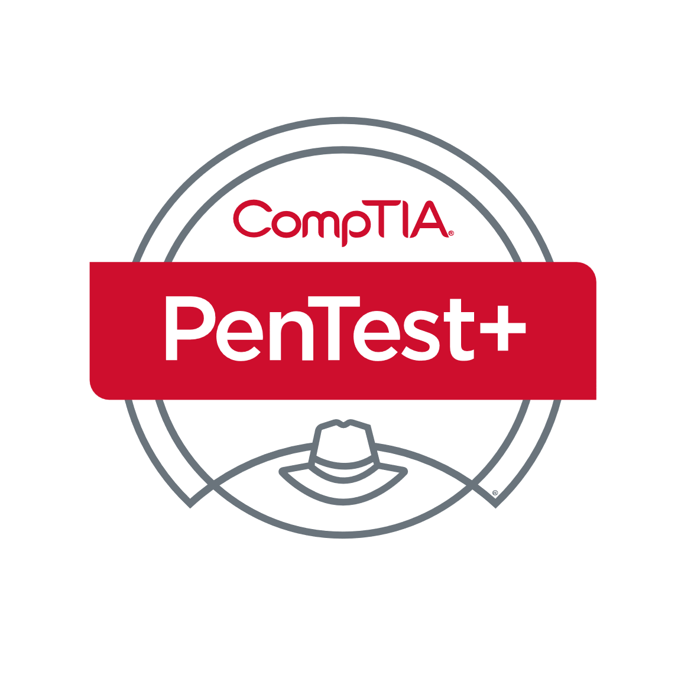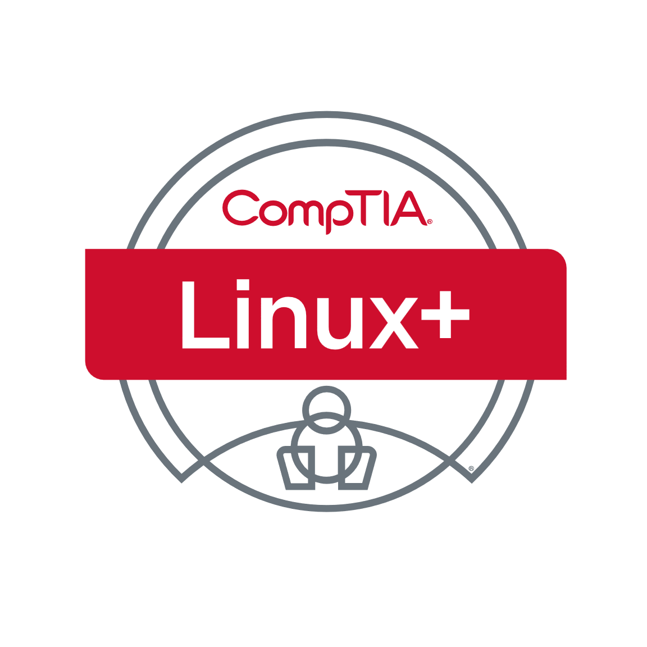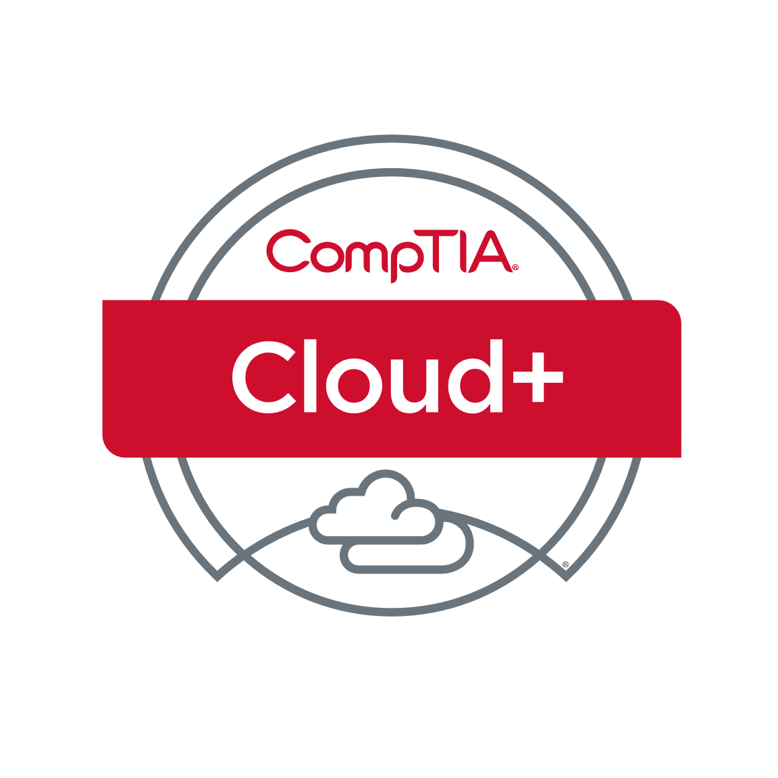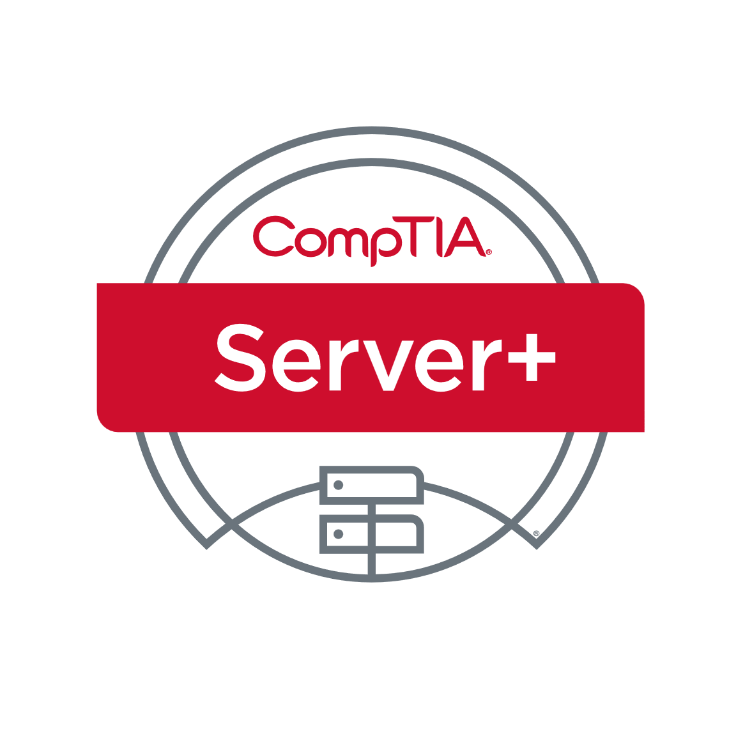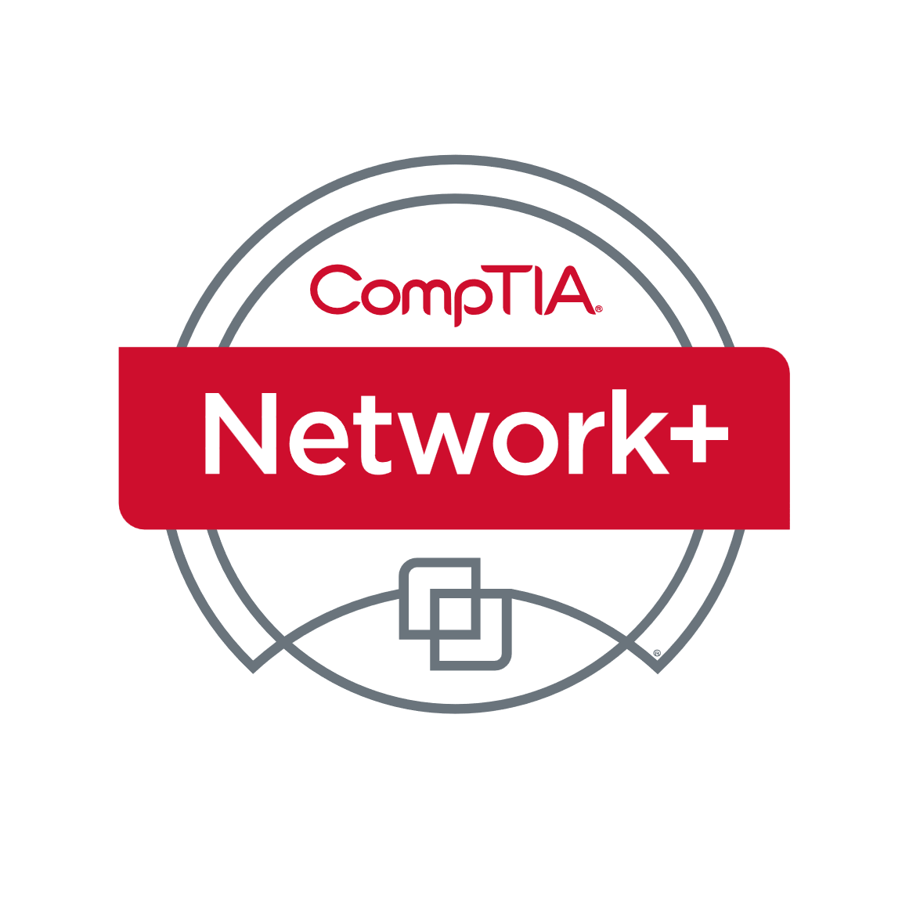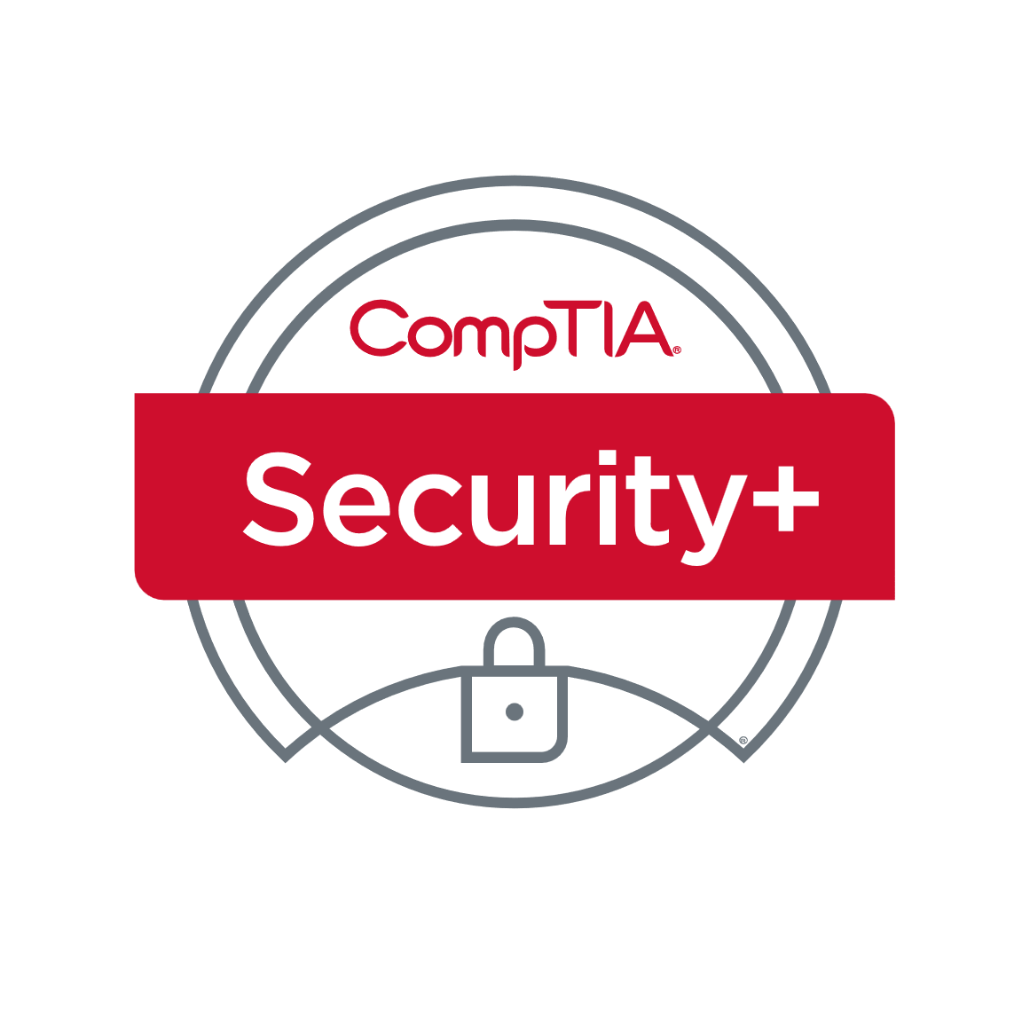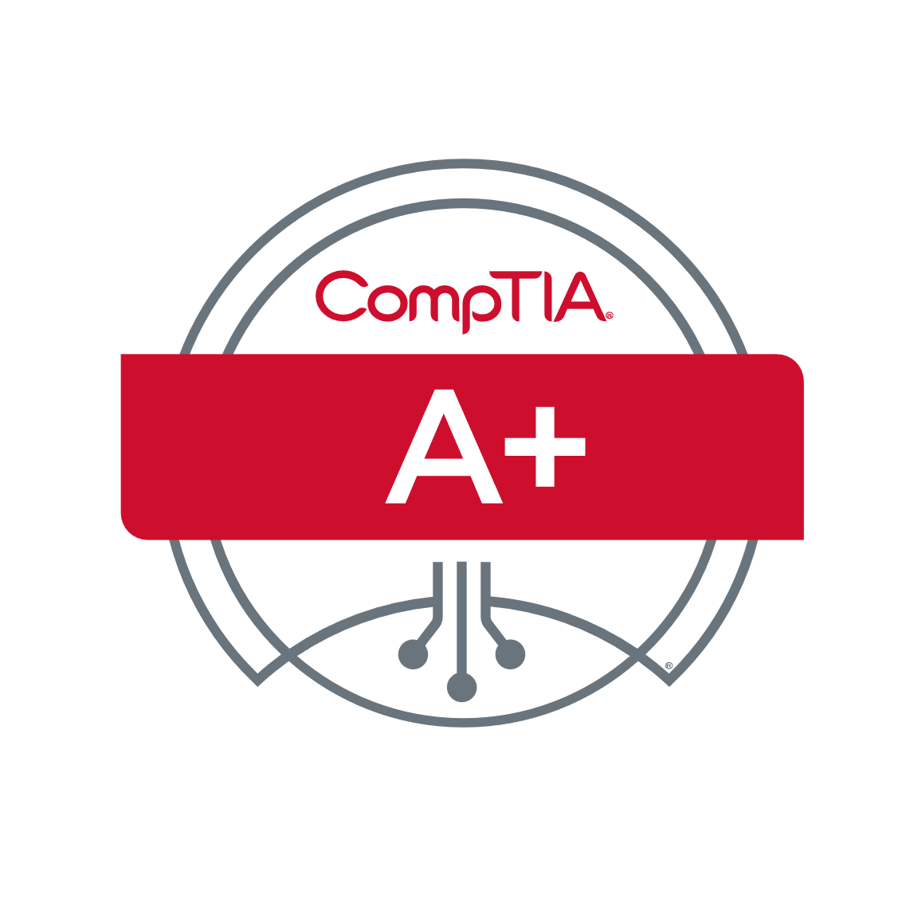

training@fastlane-mea.com

+971 (4) 42 89 440

[www.flane.ae](http://www.flane.ae)

09

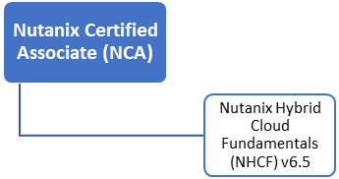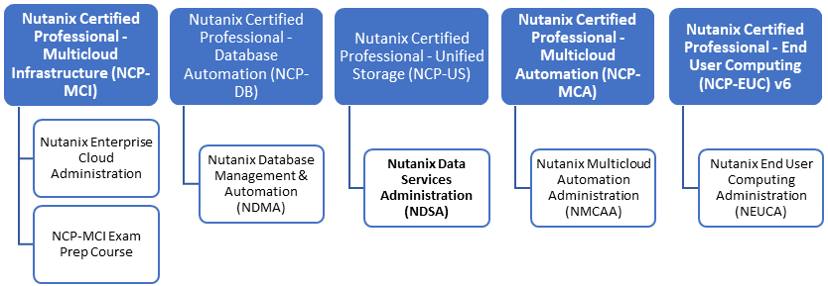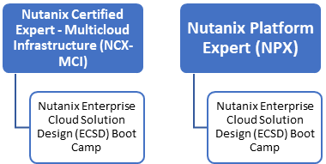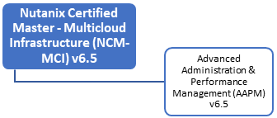

**ASSOCIATE**

**EXPERT**

**MASTER**

**PROFESSIONAL**

## Nutanix Certifications

**Contact us: training@fastlane-mea.com**

01

# (Exam CLO-002)

# (Exam PK0-005)

**Additional Professional**

**Data Analytics**

(Exam DA0-001)

**Cyber Security**

# (Exam CAS-003)

# (Exam CS0-002)

# (Exam PT0-002)

# (Exam CV0-003)

# (Exam CV0-003)

# (Exam CV0-003)

# (Exam SY0-601)

# (Exam N10-008)

# (Exams 220-1001 and 220-1002)

## CompTIA Certifications

**Certifications**

**Levels**

**Infrastructure**

**Core**

|  |  |
| --- | --- |
|  |  |
|  |  |
|  |  |
|  |  |
|  |  |
|  |  |

+971 (4) 42 89 440

10

[www.flane.ae](http://www.flane.ae)

training@fastlane-mea.com

**Specialty**

|  |
| --- |
| Customer Data Platform Specialty |
| MB-260 |

|  |
| --- |
| Azure Cosmos DB Developer Specialty |
| DP-420 |

|  |
| --- |
| Azure Virtual Desktop Specialty |
| AZ-140 |

|  |
| --- |
| Azure for SAP Workloads Specialty |
| AZ-120 |

|  |
| --- |
| Dynamics 365 Supply Chain Management Consultant Associate |
| MB-300 + MB-330 |

|  |
| --- |
| Azure Administrator Associate |
| AZ-104 |

|  |
| --- |
| Windows Server Hybrid Administrator Associate |
| AZ-800 + AZ-801 |

|  |
| --- |
| Dynamics 365 Marketing Functional Consultant Associate |
| MB-220 |

|  |
| --- |
| Dynamics 365 Sales Functional Consultant Associate |
| MB-210 |

|  |
| --- |
| Azure Security Engineer Associate |
| AZ-500 |

|  |
| --- |
| Azure Network Engineer Associate |
| AZ-700 |

|  |
| --- |
| Azure AI Engineer Associate |
| AI-102 |

|  |
| --- |
| Dynamics 365 Customer Service Consultant Associate |
| MB-230 |

|  |
| --- |
| Dynamics 365 Finance Functional Consultant Associate |
| MB-300 + MB-310 |

|  |
| --- |
| Dynamic 365: Finance and Operations Apps Developer Associate |
| MB-300 + MB-500 |

|  |
| --- |
| Dynamics 365 Field Service Consultant Associate |
| MB-240 |

|  |
| --- |
| Azure Enterprise Data Analyst Associate |
| DP-500 |

|  |
| --- |
| Azure Solutions Architect Expert |
| AZ-305 |

|  |
| --- |
| Azure Data Scientist Associate |
| DP-100 |

|  |
| --- |
| DevOps Engineer Expert |
| AZ-400 |

|  |
| --- |
| Azure DB Administrator Associate |
| DP-300 |

|  |
| --- |
| Azure Data Engineer Associate |
| DP-203 |

|  |
| --- |
| Dynamics 365 Business Central Functional Consultant Associate |
| MB-800 |

|  |
| --- |
| Dynamics 365 Finance and Operations Apps Solution Architect Expert |
| MB-700 |

|  |
| --- |
| Dynamics 365 Fundamentals(ERP) |
| MB-920 |

|  |
| --- |
| Dynamics 365 Fundamentals(CRM) |
| MB-910 |

|  |
| --- |
| Azure Data Fundamentals |
| DP-900 |

|  |
| --- |
| Azure AI Fundamentals |
| AI-900 |

|  |
| --- |
| Azure Fundamentals |
| AZ-900 |

|  |  |  |  |
| --- | --- | --- | --- |
|  | |  |  |
|  |  |  |  |
|  |  |  |  |
|  |  |  |  |

|  |  |  |
| --- | --- | --- |
|  | |  |
|  |  |  |
|  |  |  |
|  |  |  |

**Dynamics 365**

**Azure**

## Microsoft Certifications

**Fundamentals**

**Role -based**

training@fastlane-mea.com

+971 (4) 42 89 440

11

[www.flane.ae](http://www.flane.ae)

|  |
| --- |
| Security Operations Analyst Associate |
| SC-200 |

|  |
| --- |
| Identity and Access Administrator Associate |
| SC-300 |

|  |
| --- |
| Information Protection Administrator Associate |
| SC-400 |

|  |
| --- |
| Cybersecurity Architect Expert |
| SC-100 |

|  |
| --- |
| Azure Security Engineer Associate |
| AZ-500 |

**Microsoft 365**

**Specialty**

|  |
| --- |
| Power Platform Solution Architect Expert |
| PL-600 |

|  |
| --- |
| Power Platform Developer Associate |
| PL-400 |

|  |
| --- |
| Power Platform Functional Consultant Associate |
| PL-200 |

|  |
| --- |
| Power Automate RPA Developer Associate |
| PL-500 |

|  |
| --- |
| Power BI Data Analyst Associate |
| PL-300 |

|  |
| --- |
| Teams Administrator Associate |
| MS-700 |

|  |  |
| --- | --- |
| Security,Compliance and Identity Fundamentals |  |
| SC-900 |  |

|  |
| --- |
| Microsoft 365 Fundamentals |
| MS-900 |

|  |
| --- |
| Power Platform Fundamentals |
| PL-900 |

|  |
| --- |
| Power Platform App Maker Associate |
| PL-100 |

+971 (4) 42 89 440

**Role -based**

**Power Platform**

**Security, Compliance, and Identity**

**Fundamentals**

## Microsoft Certifications

training@fastlane-mea.com

[www.flane.ae](http://www.flane.ae)

12

**Contact us: training@fastlane-mea.com**

01

## VMware Certifications



**Data Center Virtualization**

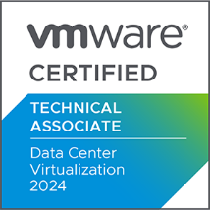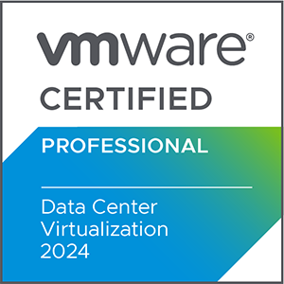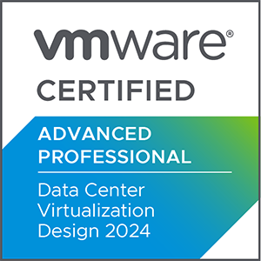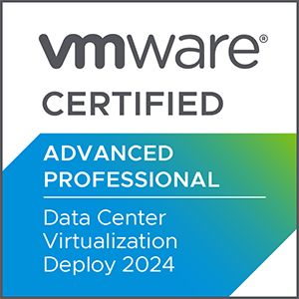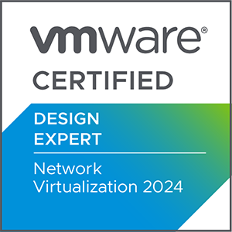

[Recommended Trainings](https://www.vmware.com/learning/certification/vcap-dcv-design.html)

[Recommended Trainings](https://www.vmware.com/learning/certification/vcdx-nv.html)

[Recommended Trainings](https://www.vmware.com/learning/certification/vcta-dcv.html)

[Recommended Trainings](https://www.vmware.com/learning/certification/vcp-dcv.html)

[Recommended Trainings](https://www.vmware.com/learning/certification/vcap-dcv-deploy.html)



**Network Virtualization**

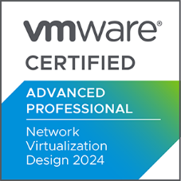

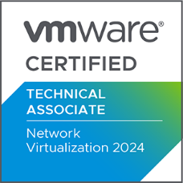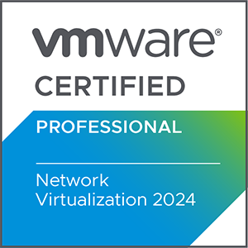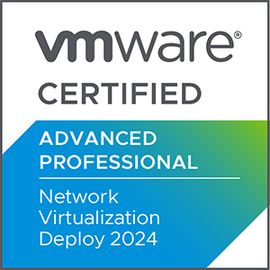



[Recommended Trainings](https://www.vmware.com/learning/certification/vcap-nv-deploy.html)

[Recommended Training](https://www.vmware.com/learning/certification/vcap-nv-design.html)

[Recommended Trainings](https://www.vmware.com/learning/certification/vcdx-nv.html)

[Recommended Trainings](https://www.vmware.com/learning/certification/vcp-nv-nsxt.html)

[Recommended Trainings](https://www.vmware.com/learning/certification/vcta-nv.html)

13

+971 (4) 42 89 440

[www.flane.ae](http://www.flane.ae)

training@fastlane-mea.com

[Recommended Trainings](https://www.vmware.com/learning/certification/vcap-nv-deploy.html)

[www.flane.ae](http://www.flane.ae)

training@fastlane-mea.com

+971 (4) 42 89 440

[www.flane.ae](http://www.flane.ae)

training@fastlane-mea.com

+971 (4) 42 89 440

[www.flane.ae](http://www.flane.ae)

training@fastlane-mea.com

+971 (4) 42 89 440

[www.flane.ae](http://www.flane.ae)

+971 (4) 42 89 440

[Recommended Trainings](https://www.vmware.com/learning/certification/vcdx-cma.html)

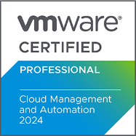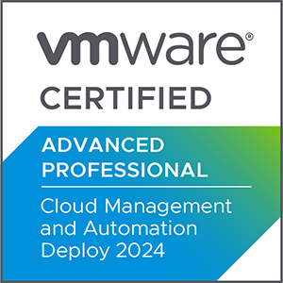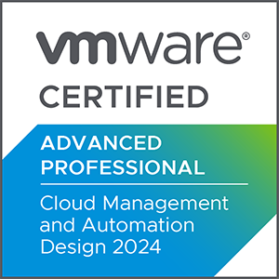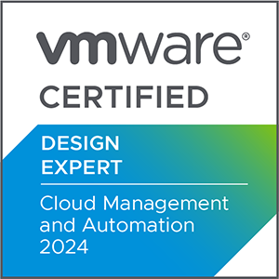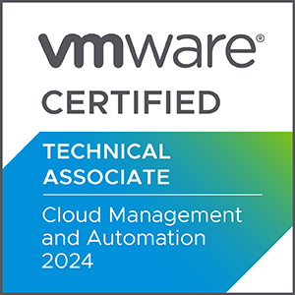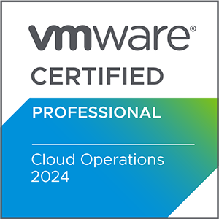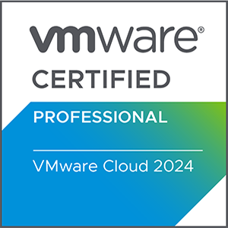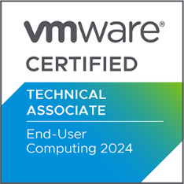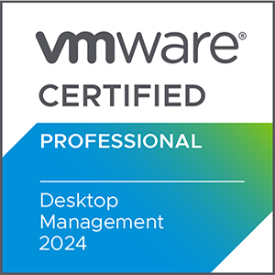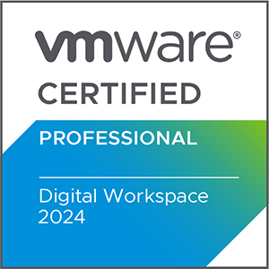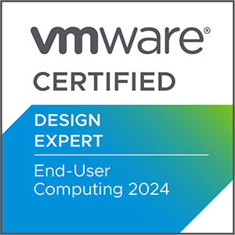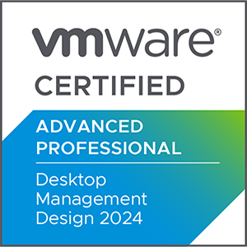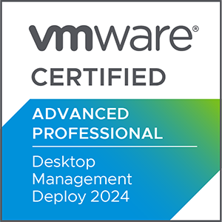

[Recommended Trainings](https://www.vmware.com/learning/certification/vcap-cma-design.html)

[Recommended Training](https://www.vmware.com/learning/certification/vcta-cma.html)s

[Recommended Trainings](https://www.vmware.com/learning/certification/vcap-dtm-deploy.html)

[Recommended Trainings](https://www.vmware.com/learning/certification/vcp-dtm.html)

[Recommended Trainings](https://www.vmware.com/learning/certification/vcdx-euc.html)

[Recommended Trainings](https://www.vmware.com/learning/certification/vcta-euc.html)

[Recommended Trainings](https://www.vmware.com/learning/certification/vcap-dtm-design.html)

[Recommended Trainings](https://www.vmware.com/learning/certification/vcp-dw.html)

VMware Certifications

[Recommended Trainings](https://www.vmware.com/learning/certification/vcp-vmc.html)

**End – User Computing**

[Recommended Trainings](https://www.vmware.com/learning/certification/vcap-cma-deploy.html)

[Recommended Trainings](https://www.vmware.com/learning/certification/vcp-cma.html)

[Recommended Trainings](https://www.vmware.com/learning/certification/vcp-cma.html)

**Cloud management & automation**

[www.flane.ae](http://www.flane.ae)

+971 (4) 42 89 440

training@fastlane-mea.com

14

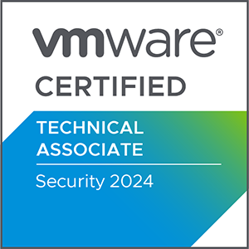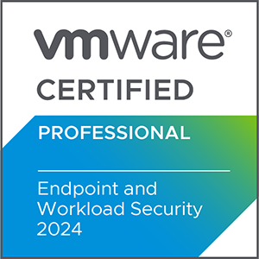

[Recommended Trainings](https://www.vmware.com/learning/certification/vcp-tko.html)

[Recommended Trainings](https://www.vmware.com/learning/certification/spring-certified-pro.html)

[Recommended Trainings](https://www.vmware.com/learning/certification/vcta-am.html)

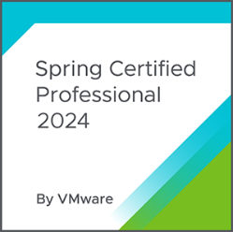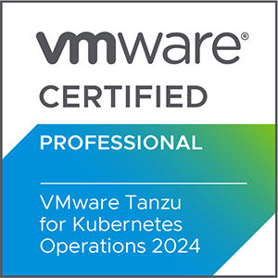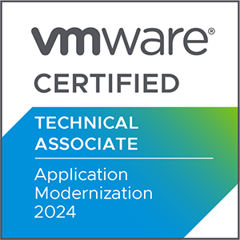

[Recommended Trainings](https://www.vmware.com/learning/certification/vcta-security.html)

[Recommended Trainings](https://www.vmware.com/learning/certification/vcp-ews.html)

**Application Modernization**

VMware Certifications

**Security**

**Security**

training@fastlane-mea.com

[www.flane.ae](http://www.flane.ae)

+971 (4) 42 89 440

+971 (4) 42 89 440

training@fastlane-mea.com

15

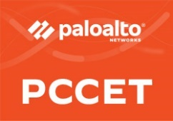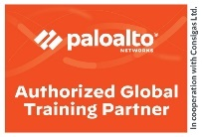

Installation, Migration and Deployment Skills

Implementation, Admin and Management Skills

Configuration and Admin skills

**Consulting Engineers**

**Security Engineers**

**Security Administrators**

**Cyber Security Entry Level**

Palo Alto Networks Certified Network Security Consultant

Palo Alto Networks Certified Network Security Engineer

Palo Alto Networks Certified CyberSecurity Associate

Palo Alto Networks Certified Security Automation Engineer

Prisma Certified Cloud Security Engineer

Palo Alto Networks Certified Network Security Admin

Cybersecurity Technical and Fundamental Understanding

|  |  |  |  |
| --- | --- | --- | --- |
|  |  |  |  |
|  |  |  |  |

+971 (4) 42 89 440

training@fastlane-mea.com

[www.flane.ae](http://www.flane.ae)

16

## Palo Alto Certifications

D

D

D

D

**Data Ethics**

**Data Science**

**Artificial Intelligence (AI)**

**Cyber Security**

**Internet of Things**

**TM**

## CertNexus Certifications

17

[www.flane.ae](http://www.flane.ae)

training@fastlane-mea.com

+971 (4) 42 89 440

18

training@fastlane-mea.com

+971 (4) 42 89 440

[www.flane.ae](http://www.flane.ae)

## VEEAM Certifications

VMCA



Overview Course: Architecture and Design

VMCE

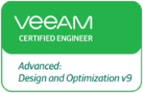

Overview Course:

Install, Configure & 44Manage

3 days + Exam



2 days + Exam



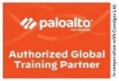

# Training Schedule

|  |  |
| --- | --- |
| Vendor | Training Schedule |
|  |  |
|  |  |
|  |  |
|  |  |
|  |  |
|  |  |
|  |  |
|  |  |
|  |  |
|  |  |
|  |  |
|  |  |
|  |  |

Click on the link to follow the

[Palo Alto Schedule](https://www.flane.ae/_files/ugd/38b5e1_5d7ac448fb2048ad85a1f876a58fb484.pdf)

[COMMVAULT Schedule](https://www.flane.ae/_files/ugd/38b5e1_b4126dec8e274e58a34771364aed7fbe.pdf)

[VEEAM Schedule](https://www.flane.ae/_files/ugd/38b5e1_a07bfe0dd85545938b3c0a765c412ad5.pdf)

[CertNexus Schedule](https://www.flane.ae/_files/ugd/38b5e1_c280475b63424f96bb80ef411bbc867c.pdf)

[VMware Schedule](https://www.flane.ae/_files/ugd/38b5e1_1ed50f44d71c4f6eb2cce92b012f3846.pdf)

[Microsoft Schedule](https://www.flane.ae/_files/ugd/38b5e1_5d83c6313e4044da8e97361ddfd7afa8.pdf)

[CompTIA Certifications](https://www.flane.ae/_files/ugd/38b5e1_2451f6b0351047b29af8657a1c604cc6.pdf)

[Nutanix Schedule](https://www.flane.ae/_files/ugd/38b5e1_2aebe06c5cda489e8372f269acc135c2.pdf)

[Infoblox Schedule](https://www.flane.ae/_files/ugd/38b5e1_7a93b558fddc4a95aecb841d64ceda33.pdf)

[Aruba Schedule](https://www.flane.ae/_files/ugd/38b5e1_ef22acab7683473784873b681715235a.pdf)

[Fortinet Schedule](https://www.flane.ae/_files/ugd/38b5e1_671fa83d29274a85b4572f9125128ca4.pdf)

[NetApp Schedule](https://www.flane.ae/_files/ugd/38b5e1_1ad7969675fd45beb732840db8239db3.pdf)

[Cisco Schedule](https://www.flane.ae/_files/ugd/38b5e1_a9bcda74bbdc418fa6ba1e9c63ff7555.pdf)

+971 (4) 42 89 440

training@fastlane-mea.com

[www.flane.ae](http://www.flane.ae)

19